Beyond Cooked
Game Design Document
By: Quan Hoang

Game Summary
Beyond Cooked is a chaotic co-op cooking game in space and different planets. Players must prepare dishes under extreme conditions: zero gravity, possessed appliances, and rogue ingredients that fight back. Success requires communication (hopefully proximity chat). Players land on a different planet each level, their rocket is their kitchen and they need to venture out (similar to lethal company) to gather ingredients or tools and cook it in their rocket to satisfy their galactic customers.

Pillars
3 Forms of Fun:
Comedy
Thrill of Danger
Social Interaction

Player Experience
Core Loop:
- Land: Players arrive on a planet with a list of dishes to serve and a limited time.
- Explore: Venture outside the rocket to gather alien ingredients and tools (some are alive or dangerous).
- Cook: Back in the rocket, prepare the dishes while handling environmental chaos (gravity shifts, possessed appliances, alien pests).
- Serve: Deliver the dishes to customers via a galactic order system. Earn points and reputation.
- Upgrade & Travel: Between missions, use earned credits to upgrade your ship, unlock new recipes, or repair damaged modules.
Low-Level Verbs: Pick up, throw, chop, cook, dodge, repair, communicate.
High-Level Verbs: Explore, cooperate, strategize, survive, laugh.

Story
A colossal cosmic horror known only as The Devourer of Worlds has awoken from its thousand-year nap, and its hangry. This interstellar creature travels the galaxy, threatening to swallow entire planets unless it’s served gourmet food worthy of its infinite taste buds.
You and your crew of rookie space chefs are the galaxy’s last hope (and, let’s be honest, last-minute replacement). Armed with a duct-taped rocket and minimal culinary training, you’ve been “volunteered” by the GCF (Galactic Culinary Federation) to satisfy the monster’s appetite before it turns your homeworld into an appetizer.
Your mission:
Hop from planet to planet, scavenging bizarre ingredients and cooking in chaotic environments to meet the creature’s daily food quota. If you don’t serve it in time… you and your planet become lunch.
Your goal?
Cook to survive. Feed the beast. Save the galaxy (probably).

Inspiration
My game is heavily inspired by Overcooked and Lethal Company. I really want to replicate the chaotic, a tiny bit scary yet fun emotions that I felt when I played these games, especially with my friends. Mechanics and gameplay-wise, the game will combine the orders/cooking/serving mechanism of Overcooked and the exploration/movement/world generation/procedural generation/Monsters of Lethal Company.

Target Audience
Casual gamers (ages 13-30) who enjoy co-op party games, chaotic physics, and humor.

What they like:
- Fast-paced teamwork (Overcooked, Moving Out)
- Funny, replayable multiplayer sessions (Goose Goose Duck, Lethal Company)
- Games that are easy to learn but chaotic in execution

Primary Mechanics
What are the main actions a player does in the game, and how does the game respond to those actions? What rules govern the game continuously?

Scope
Size:
- 2 planets (levels) for the prototype, each with 1–2 recipes.
- Each planet will have ~5 monsters
- 4 main character types (customizable suits).
- 10+ ingredients and 5 appliances.
Each planet introduces a new mechanic, monsters. The stretch aim is to make world generation/procedural generation and potential make “infinite levels” (similar to Lethal Company) based on planet “templates”

Interface
How does the player interact with the game? How do they perform various actions? What information is displayed to the player? What menus do you need?
Player Interactions:
- Keyboard/controller movement
- “Grab/Throw” button
- “Action” button for chopping, cooking, repairing, using the items you picked up
- Voice or text chat for coordination

Display:
- UI should be kept minimal, only Health, Stamina,... (Similar to Lethal Company)
- Info would be displayed through screens (or other) in game
Menus:
- Main Menu (Play, Settings, Credits)
- Lobby/Character select
- Pause menu (Resume, Restart, Exit)

Art / Graphics
3D. This cartoonish yet a little bit realistic, horrish style like Lethal Company. I’d like to make the game be a little scary but not too scary

References:
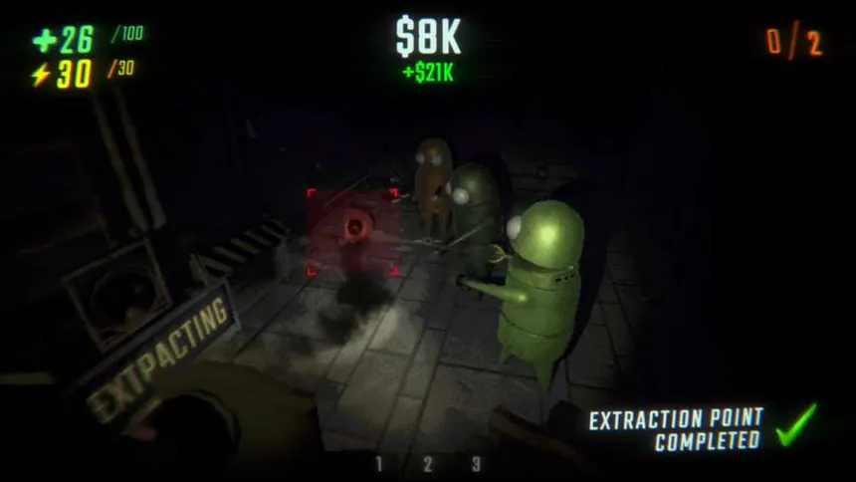
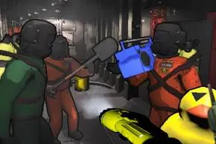

Assets used would be a mixed of self made and external assets

Music / Audio
Since it’s a survival/exploration/horrish game, I’d keep music to a minimum and focus more on sound effects which I’d acquire online.

Risks
Hardest parts:
Procedural Generation: Creating unique planets that feel dynamic and fun.
→ Mitigation: Start with fixed maps, then gradually add simple randomization.
Assets Acquisition: Finding or making 3D models that match the art style.
→ Mitigation: Use free asset packs first, then replace with custom ones later.
Online Multiplayer: Syncing actions (throwing, cooking, monsters) over the network.
→ Mitigation: Begin with local co-op; add online play once the base gameplay works.

Prototype Plan
1 playable level (small planet)
1–2 simple recipes (e.g., Alien Soup, Space Burger)
1–2 basic monsters that chase or annoy players
Basic player movement + grab/throw actions
A rocket base (the kitchen) with 2–3 appliances (chopping board, stove, serving counter)
Simple UI for timer and recipe orders
Basic multiplayer or local co-op (if possible)

